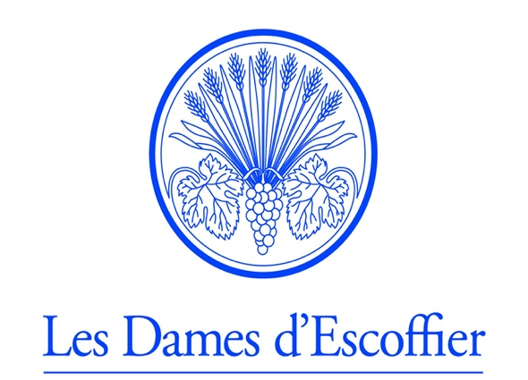

Les Dames d’Escoffier – Portland Chapter
Fancy Food Show Mentorship Application

Deadline: Application due by midnight March 31st, 2023
The scholarship winner will be announced April 7th, 2023

Call to applicants: 2023 Fancy Food Show Booth/Mentor Scholarship Available

The Les Dames d’Escoffier International (LDEI) Portland chapter is excited to support and mentor one woman-owned food/beverage business at the June 25-27, 2023, Fancy Food Show in New York City. In partnership with the Food Innovation Center, Les Dames Portland will provide one culinary professional with a complimentary booth in the incubator village, as well as professional mentorship to help prepare for the trade show opportunity including packaging design, marketing/PR, sales sheet review, pitch coaching, etc.

Scholarship applicants must identify as a woman-owned business, have worked with/or have a scheduled appointment with the OSU food innovation center, and be ready for wholesale orders by the tradeshow date.

LDEI is an international organization of women leaders who create a supportive culture in their communities to achieve excellence in the food, beverage, and hospitality professions. More than 2,300 members in 40 chapters worldwide provide leadership, educational opportunities, and host philanthropic events within their communities. The Portland chapter will pay the booth fee and Specialty Food Association registration ($600 + $200) for the scholarship winner, directly to Oregon State University’s Food Innovation Center. The winner will be responsible for transportation and lodging to and from the event.

We believe that historical bad behavior in the food and wine industry disproportionally hurts the most marginalized people in society, including women of color, women from working-class backgrounds, and LBGTQ people. We believe that these communities must be centered in the work we do to lift up women in our food community. Hence, we strongly encourage applications from people with these identities or who are members of marginalized communities to apply. If you would like translation assistance for this application email sarahspicymarshall@gmail.com and we will connect you with a volunteer.

Please complete the following:

I. Background Information
Name/Organization _________________________________________________________________

Tax ID Number _________________________________________________________________

Contact Name, Title _________________________________________________________________

Secondary Contact _________________________________________________________________

Contact Phone ____________________ Contact Email ______________________________

Secondary Contact Phone __________________ Email ___________________________________

Organization Address ________________________________________________________________

City/State/Country _____________________________________________ Postal Code: _____________

Website Address: ___________________________________________________________________

Year of Incorporation: ___________

Staff Composition in Numbers:
Paid full time
Paid part-time
Volunteers

II. BUSINESS NARRATIVE
Organization mission and vision statements:

Description of Business:

Connection to Community:

LDEI Mentor Initiative Focus:
How will your business benefit from this scholarship?

What areas of mentorship are you seeking?

How would sponsoring your business benefit the community?

What barriers to accessing or attending this type of show exist for you?

Goals and Objectives:
What are the measurable goals of attending the Fancy Food Show?

What objectives do you plan to focus on at the event?

How can we help?

What is your connection to Oregon State University Food Innovation Center? Have you used their services, or do you plan to use their services?

Change in financial status:
Have there been any notable changes in your annual funding sources over the past year or do you anticipate any in the coming year?

How will this scholarship help your business financially?

Signature of Authorized Official: _____________________________ Your Title: ___________________________ Date: ______________________________
Please submit applications to:
Sarah Marshall, Marshall’s Haute Sauce
sarahspicymarshall@gmail.com

